**API – Add Product**

http://127.0.0.1:8080/api/products/addProduct

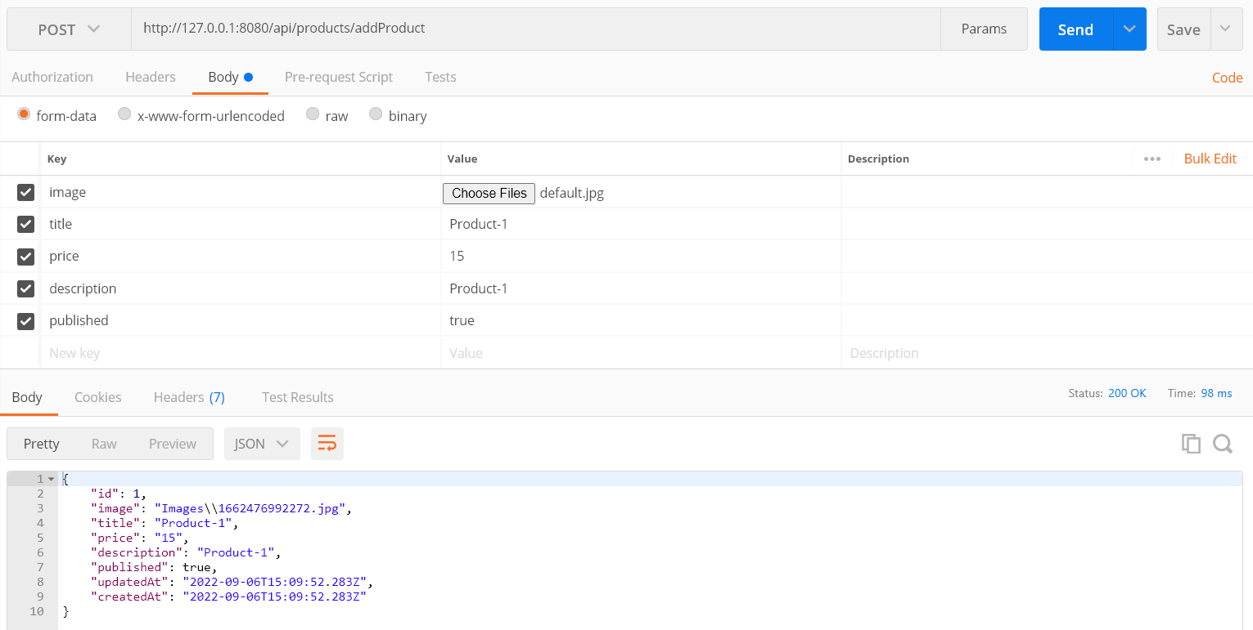

**API – Product Review**

http://127.0.0.1:8080/api/products/getProductReviews/1

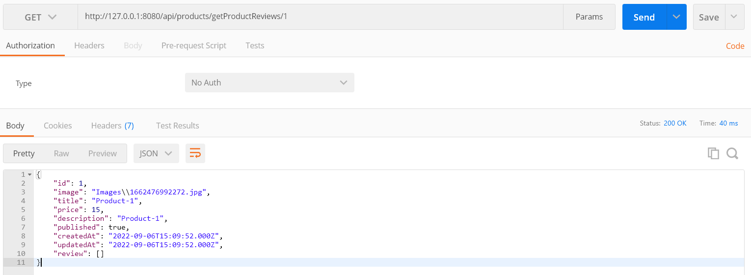

**Add Product**

http://localhost:3000/addProduct

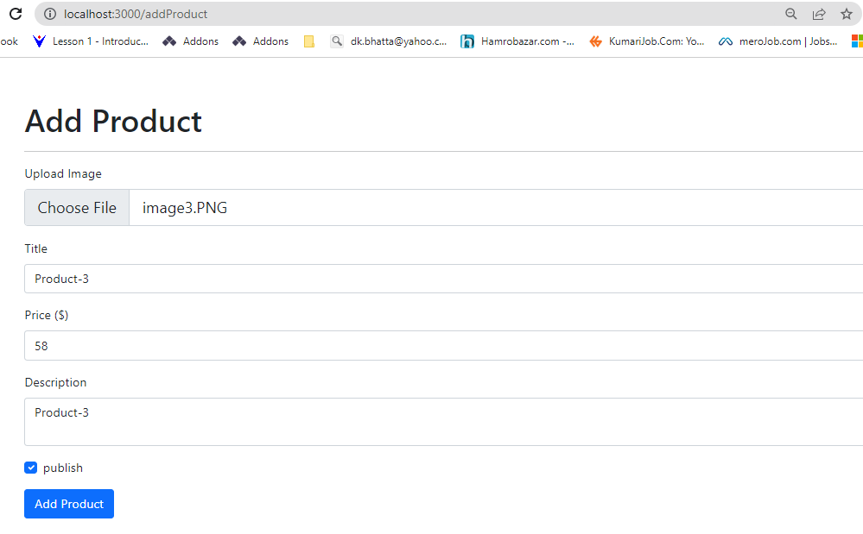

**Display All Products**

http://localhost:3000/products

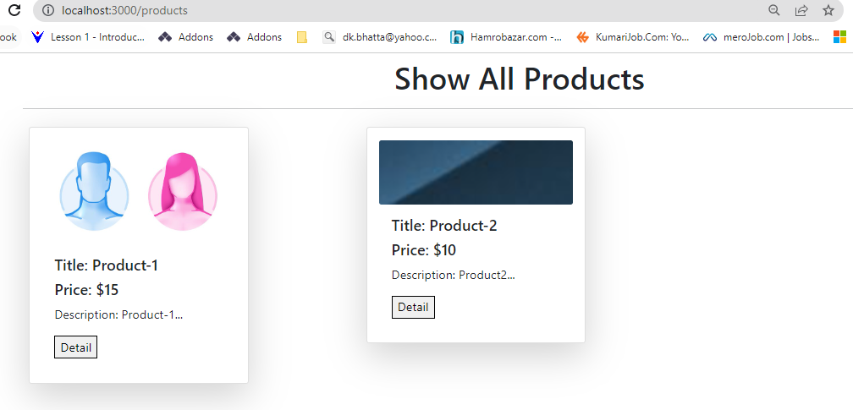

**Update Product**

**http://localhost:3000/product/edit/2**

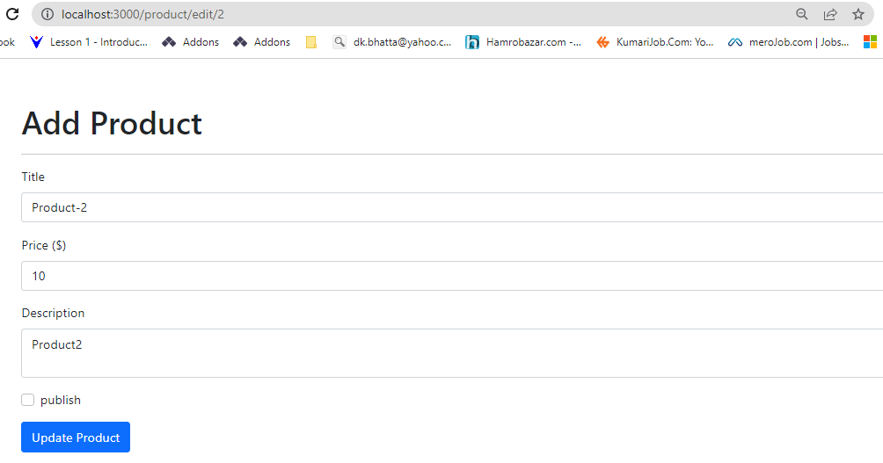

**Search Individual Product**

http://localhost:3000/product/ 2

